**Abstract**

The data for this project represents how our users use Tinder. We collect data on every person a user swipes on to the number of messages that are exchanged. The purpose of this study to analyze data, and answer some questions such as the how many male or female use system, on average how many messages are sent and how many received etc. I will answer following questions in this study. This study shows that on average basis, females sent less swipes, likes and messages as compared to males and vice versa in receiving. Users of age group 18 to 28 years are main target audience.

**Research Questions (RQs)**

1. Basic Exploratory Data Analysis
2. Who sent/ receive more swipes on average by following
   1. Which country users?
   2. Male or Female?
   3. Android or IOS users?
   4. Day wise average swipes sent by users?
3. Who sent/ receive more average likes on average by following
   1. Which country users?
   2. Male or Female?
   3. Android or IOS users?
   4. Day wise average swipes sent by users?
4. Who sent/ receive more average number of messages on average by following
   1. Which country users?
   2. Male or Female?
   3. Android or IOS users?
   4. Day wise average swipes sent by users?
5. What is probability of having match for users knowing the features such as gender, swipes sent/ received, likes sent/ receive, messages sent/ receive etc., using machine Learning Algorithm. (**Classification Problem**)
6. Next time knowing above features, how many matches are possible in login using Machine Learning Algorithm (**Regression Problem**)
7. Recommendation System: Recommending users which are most likely to pair-up/ match with each other based on available features such as likes, swipes and messages send/ received. (**using machine learning k-NN algorithm**)

**RQ1: Data Description**

There are 35780 rows and 14 columns/ potential features in given dataset. The dataset contains no missing values. Following is the data dictionary of each of the column.

* user_id​ : unique identifier for each user
* day​ : the day in which data was collected on the user
* age​ : the user’s age on that day
* country​ : the country where a user resided on that day
* gender​ : the user’s gender (female or male)
* device_type​ : the type of device the user was using on that day (android or ios)
* is_active_user​ : whether the user opened the app that day (1 = Yes, 0 = No)
* swipes_sent​ : the number of people the user swiped on that day
* swipes_received​ : the number of people that swiped on the user on that day
* likes_sent​ : the number of people the user swiped right (liked) on that day
* likes_received​ : the number of people who swiped right on (liked) a user on that day
* matches​ : the number of people the user matched with on that day. matches occur when two people swipe right on (liked) each other
* messages_sent​ : the number of messages the user sent on that day
* messages_received​ : the number of messages the user received on that day

**This data is of 1 year and 1 month.**

**Data Types**

Table 1: Data Types

|  |  |  |
| --- | --- | --- |
| **Feature** | **Data Type** | **Pre-processing Done** |
| user_id | Integer | - |
| day | Object | Convert to date time datatype  Extract Year, Month, Day |
| age | Integer | There was age issue for same users |
| country | Object | - |
| gender | Object | - |
| device_type | Object | - |
| is_active_user | Integer | - |
| swipes_sent | Integer | - |
| swipes_received | Integer | - |
| likes_sent | Integer | - |
| likes_received | Integer | - |
| matches | Integer | - |
| messages_sent | Integer | - |
| messages_received | Integer | - |

**Data Unique Values for each Column**

|  |  |
| --- | --- |
| **Feature** | **Unique Values** |
| user_id | 2198 |
| day | 31 |
| age | 47 |
| country | 5 |
| gender | 2 |
| device_type | 2 |
| is_active_user | 2 |
| swipes_sent | 1030 |
| swipes_received | 1216 |
| likes_sent | 242 |
| likes_received | 637 |
| matches | 84 |
| messages_sent | 276 |
| messages_received | 193 |

**Issue(s) With Data**

1. **Invalid Values**

There is some issue with some users, like they have same user ID, country and gender but different age, which is not possible. So i will remove such duplicates to make our analysis clear. There are 150 such users which contain duplicate/ erroneous ages for users. Solution is to ignore one of the values.

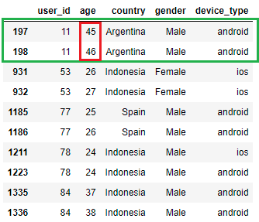

1. **Outliers/ Anomalies**

There were some values which might be outliers in some features as shown.

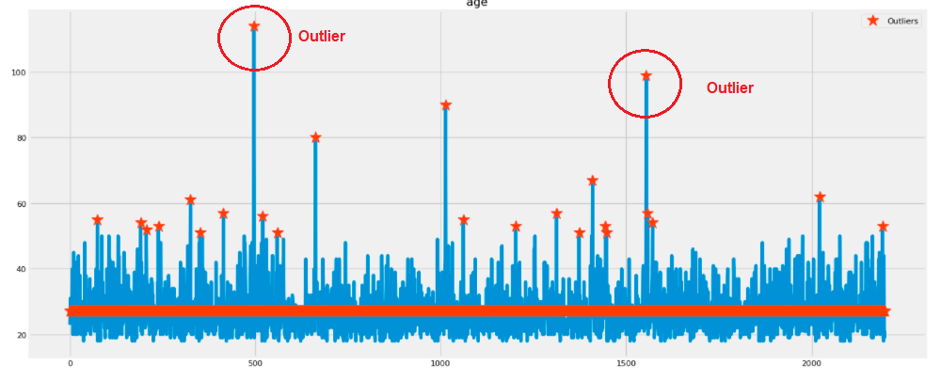

Fig 1: Values such as 114 and 89 in age are outliers

Table 3: Country Wise Users Distribution

|  |  |
| --- | --- |
| **Country** | **Percentage of Users** |
| Argentina | 18.79% |
| Indonesia | 16.15% |
| Italy | 14.38% |
| Spain | 28.25% |
| Thailand | 22.43% |

|  |  |  |
| --- | --- | --- |
| **Country** | **Male** | **Female** |
| Argentina | 15.02% | 24.22% |
| Indonesia | 21.26% | 8.78% |
| Italy | 12.94% | 16.44% |
| Spain | 25.50% | 32.22% |
| Thailand | 25.27% | 18.33% |

Table 4: Gender Wise Users Distribution

|  |  |
| --- | --- |
| **Country** | **Percentage of Users** |
| Female | 40.95% |
| Male | 59.05% |

Table 5: Device Type Wise Users Distribution

|  |  |
| --- | --- |
| **Country** | **Percentage of Users** |
| Android | 58.37% |
| IOS | 41.63% |

Table 6: Day Wise Users Distribution

|  |  |
| --- | --- |
| **Country** | **Percentage of Users** |
| Friday | 16.12% |
| Monday | 12.97% |
| Saturday | 12.79% |
| Sunday | 12.91% |
| Thursday | 16.15% |
| Tuesday | 13.07% |
| Wednesday | 16.00% |

Table 7: Status (Active/ Not Active) Users Distribution

|  |  |
| --- | --- |
| **Country** | **Percentage of Users** |
| 0 (Not Active) | 39.95% |
| 1 (Active) | 60.05% |

Most of the users are the age bracket 18 to 32 years.

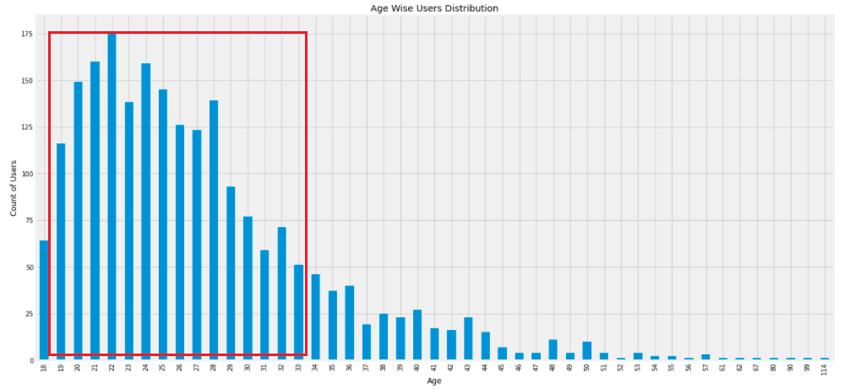

Fig 2: Age Wise User Distribution

**RQ2: Swipes Sent/ Received**

* Male (65 on average) sent swipes more frequently than Female (62 on average)
* Alternatively, Male (64 on average) received swipes more frequently than Female (125 on average)

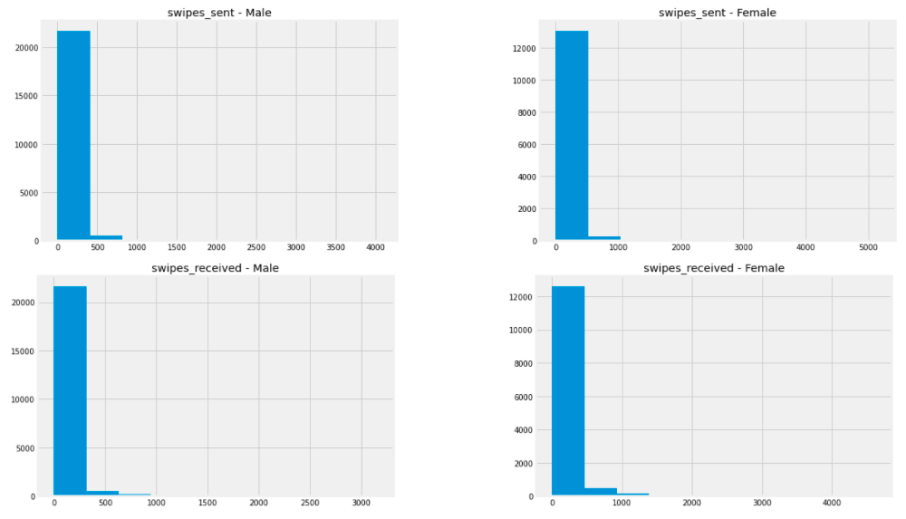

Fig 3: Gender Wise Swipes Sent/ Received

**RQ3: Likes Sent/ Received**

* Male (12 on average) sent likes more frequently than Female (6 on average).
* Male (10 on average) received likes more frequently than Female (46 on average)

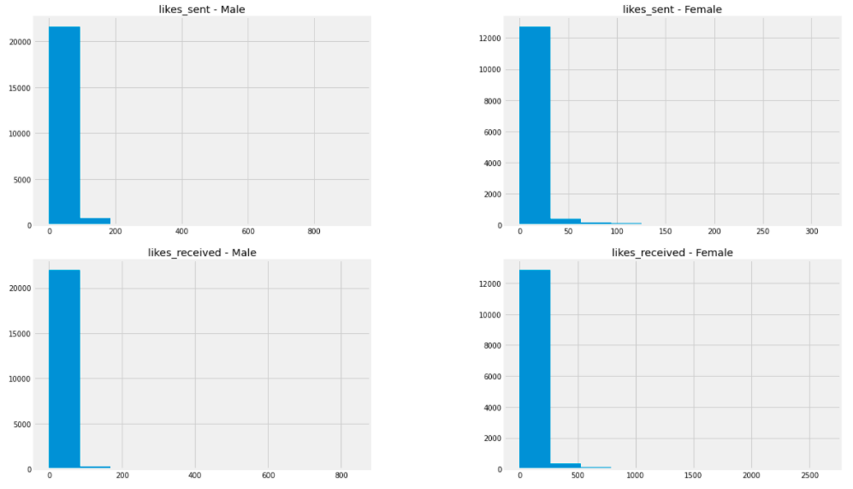

Fig 4: Gender Wise Likes Sent/ Received

**RQ4: Messages Sent/ Received**

* Male (7 on average) sent messages more frequently than Female (6 on average).
* Male (7 on average) received messages same as Female (7 on average)

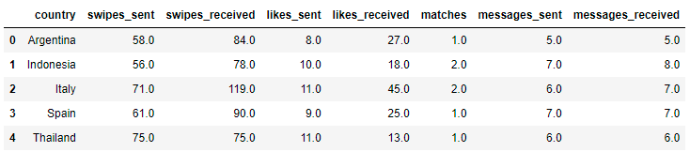

Fig 5: Country Wise Average Swipes/ Likes/ Messages - Sent/ Received

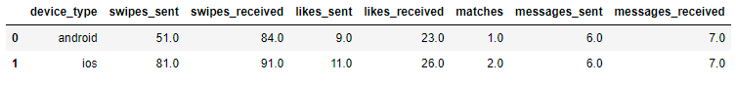

Fig 6: Device Type Wise Average Swipes/ Likes/ Messages - Sent/ Received

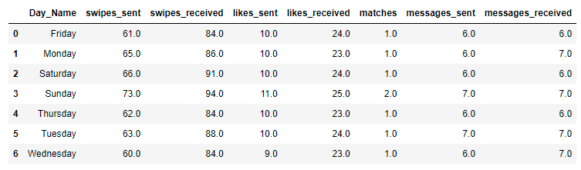

Fig 7: Day Wise Average Swipes/ Likes/ Messages - Sent/ Received

**RQ5: Classification Algorithm (Machine Learning Algorithm)**

* What is probability of having match for users knowing the features such as gender, swipes sent/ received, likes sent/ receive, messages sent/ receive etc., using machine Learning Algorithm. (**Classification Problem**)

Random Forest Algorithm is used to predict whether user will have a match with other user or not? This will help us in advance the potential candidates with having high probability of having match when become active. We can use this information for many purposes such as advertisements, promotion or any other purpose (like marketing of the application).

**Classification Report – Evaluation**

precision recall f1-score support

0 0.77 0.80 0.79 2915

1 0.83 0.80 0.82 3530

accuracy 0.80 6445

macro avg 0.80 0.80 0.80 6445

weighted avg 0.80 0.80 0.80 6445

Table 8: Performance Evaluation - Classification

|  |  |
| --- | --- |
| **Parameter** | **Value** |
| Accuracy | 80% |
| Precision | 80% |
| Recall | 80% |
| F1-Measure | 80% |

**Classification Report – Evaluation**

|  |  |  |
| --- | --- | --- |
|  | Not Matched | Matched |
| Not Matched | 2340 | 575 |
| Matched | 690 | 2840 |

The Algorithm trained well on the dataset.

**Feature Importance**

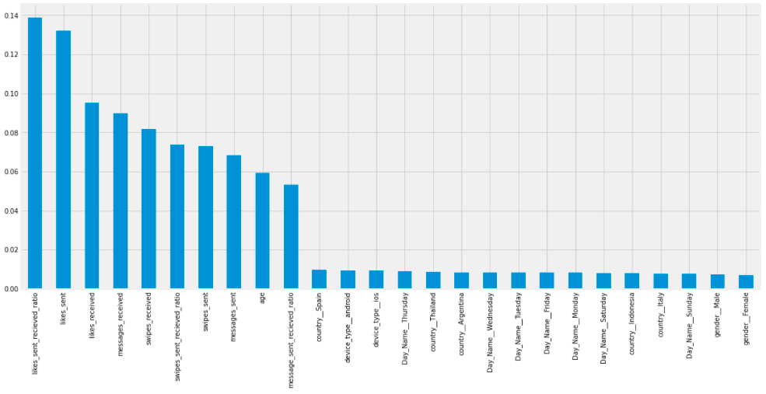

Fig 5: Feature Importance in Machine Learning - Classification

**ROC Curve**

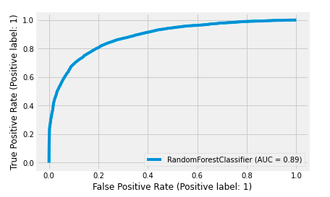

Fig 6: ROC Curve

**RQ6: Regression Algorithm (Machine Learning Algorithm)**

* Next time knowing above features, how many matches are possible in login using Machine Learning Algorithm (**Regression Problem**)

This method is used to find the number of possible matches when next time user become active on the basis of features such as swipes sent so far, received so far, likes or messages etc. Same as classification this will help application to increase customer interaction.

**Evaluation Matrices**

Table 9: Performance Evaluation – Regression

|  |  |
| --- | --- |
| **Parameter** | **Value** |
| Mean Squared Error (MSE) | 7.50 |
| Mean Absolute Error (MAE) | 1.22 |
| Root Mean Square Error (RMSE) | 2.73 |
| R-Squared | 0.74 |

**Prediction for Evaluation of Algorithm**

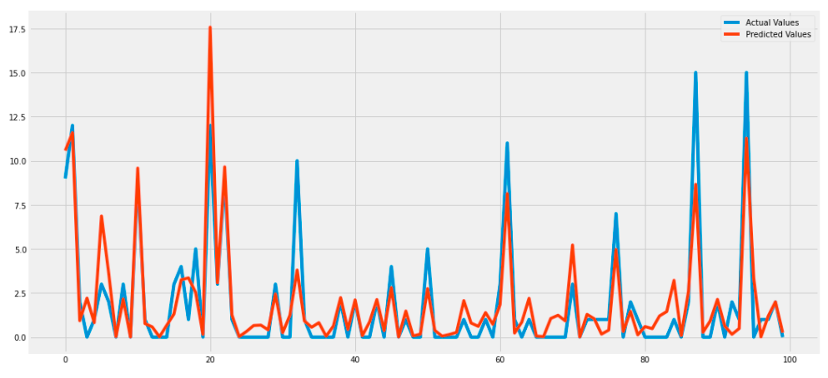

Fig 7: Actual Vs Predicted Values – Regression

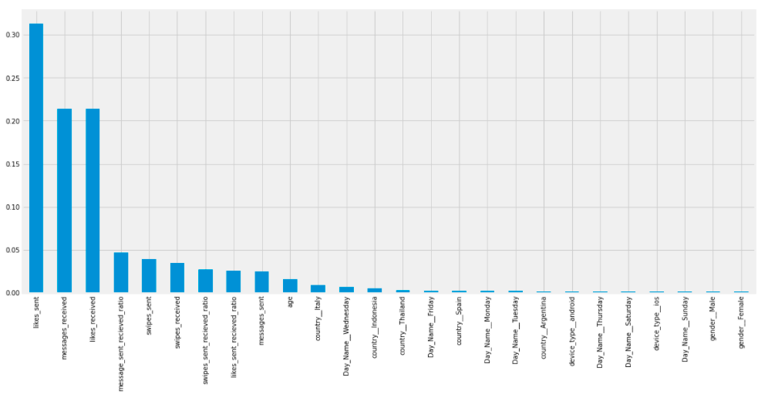

Fig 8: Feature Importance in Machine Learning – Regression

**RQ7: Recommendation System**

* Recommendation System: Recommending users which are most likely to pair-up/ match with each other based on available features such as likes, swipes and messages send/ received. (**using machine learning k-NN algorithm**)

This module will help us to increase user interaction with application. We can recommend users to user based on their similarities. This increase chance of user matches because similar users will interact with each other.

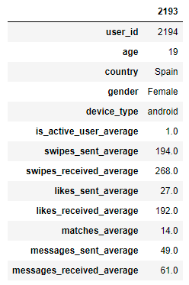

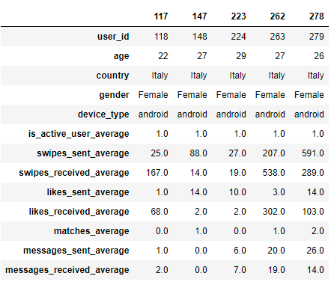

Fig 9: Recommended users to user ID: 2193

**A recommendation on what you would do next with your work**

The given dataset is useful for analysis, so I have performed basic exploratory data analysis as well some algorithms such as classification, regression and recommendation system. If you provide me full dataset (like the interaction between two users, other attributes of users, large data (of many months/ years), I can develop more sophiscated system. I can develop system which can improve system usage, we can increase users’ interaction with system by identifying the users’ behavior. I can write best match algorithm.